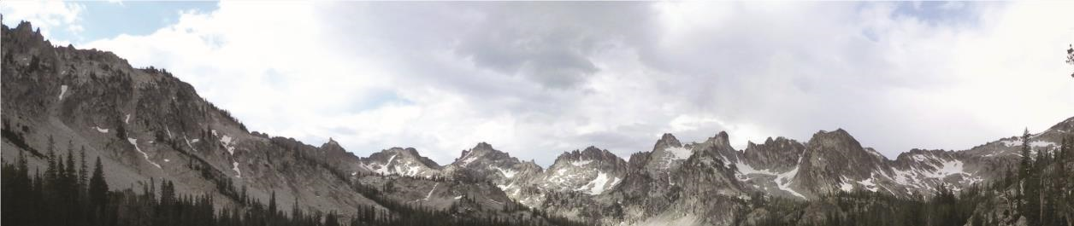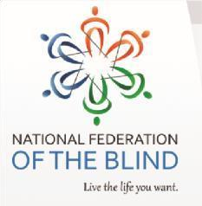

GEM STATE MILESTONES

Allan Schneider, Editor • Dana Ard, President •
aaschneider@hotmail.com pres.nfbidaho@gmail.com
(208) 870-4831 (208) 345-3906

President’s Address Dana Ard, President, NFB of Idaho
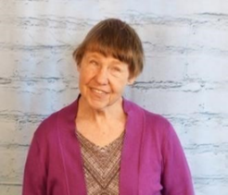
In the National Federation of the Blind of Idaho, there are two major events to report. The first was our Washington Seminar, which was held 29-February 1. Susan Bradley, Cindy Barajas, and I represented our affiliate and met with our senators and representatives. Our 3 pieces of
Photo: Dana Ard legislation were the Website and Software Applications Accessibility act: Medical Device Nonvisual Accessibility Act S.3621, and Americans Return to Work Act. Members need to contact Senators Risch and Crapo and ask them to cosponsor S.3621, which is a bipartisan bill. You can contact the senators’ offices through the Capital Switchboard at 202-224-3121. Since our return from the Washington Seminar, everyone needs to contact our senators and representatives about our important legislation. We need to get it passed.
Our state convention is March 21-24 at the Best Western Burley Inn and Conference Center, 800 N. Overland Ave. Burley, Id. 83318, phone 208 678-3501. Room rates are $99.00 per night; with tax the total is approximately $106.00. When you register, let them know you are requesting the NFB of Idaho room block. You can also specify where you want your room to be, i.e. on the first floor, near the convention center, etc. Our national representative is Norma Crosby, the president of the Texas affiliate. That affiliate has some amazing projects, and is very active with NFB Newsline. Norma’s husband, Glenn, was a small business owner and will be able to add to our program on small business. The convention committee has been working hard to make this a dynamic, ambitious event. (Continued on page 6)
Cycle for Independence Sponsor Spotlight
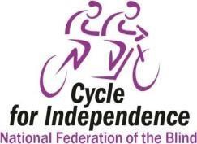
In a testament to company goodwill and community empowerment, Hyndman Insurance is a proud sponsor of the Cycle for Independence fundraiser. This event unites passionate cyclists on a mission to support independence within the blind community.
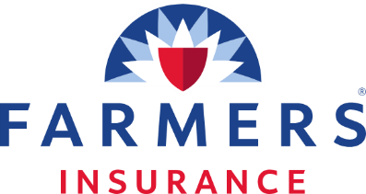
Cyclists pedaled with determination and purpose, raising awareness and funds for the National Federation of the Blind (Idaho). It also showcases how Hyndman Insurance can be a driving force for positive change.
Hyndman Insurance is a broad line insurance agency offering Home, Auto, Commercial and Life insurance across nine states. Our purpose is to evaluate client’s risk and help them make good decisions on coverage and cost. We look forward to our continued participation in the Cycle for Independence.

Book Club Update
Joe Thompson
Our book selection for February 14 is:
Tom Lake by Anne Patchett.
DB 116555
Narrated by Meryl Streep.
Attention: Due to the low turnout for this book club I have a short survey to gauge the interest of readers.
1. Is the day and time of Wednesday at 6 PM mountain time an issue? If so, please suggest a better alternative.
2. Can you suggest any books that you would like to read and discuss?
3. Is the book club ZOOM format unappealing to you?
It would be nice to have more participation.
I find it an enjoyable social hour of fellow Federationists getting to know each other a little better.

Heard Birds
Steve Bouffard-Curator of Birds, Orma J. Smith Museum of Natural History-College of Idaho

Now is a good time to listen for winter birds. Besides the local geese, ducks, crows, magpies and pigeons, there is good variety of birds to listen for. Some species are present all year, like American Robin and Cedar Waxwings, while others, such as Townsend’s Solitaires, Bohemian Waxwings, Varied Thrushes and Pine Grosbeaks join the winter bird fauna. These feed primarily on fruits such as crab apples and juniper berries. Some, like Bohemian Waxwings, Varied Thrushes, and Evening Grosbeaks, show up every winter. Others, like the Pine Grosbeaks, show up every few winters; these are referred to irruptive species.
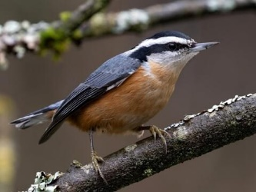
For those of you who have bird feeders, you can also hear a variety of seed-eating birds. The usual birds heard around feeders include Red-breasted Nuthatch, Black-capped Chickadee, House Sparrow, House Finch, American and Lesser Goldfinches, Dark-eyed Juncos, Mourning and Eurasian Collared Doves, and Song and White-crowned Sparrows. Most of these are present year round, but the White-crowned Sparrow and Juncos come to lower elevations during the winter. Irruptive species that rarely are heard around bird feeders are Common Redpoll and Rosy-Finches. All the birds flocking to bird feeders attract predators such as Sharp-shinned and Cooper’s Hawks and Merlins. These raptors are usually quiet during the winter, but when they show up, you will hear a lot of alarm calls from the seed eaters. Another bird that has been overwintering in the Treasure Valley in the last decade or so is Anna’s Hummingbird. They are feeding from heated nectar feeders. If you hear hummingbird wings during the winter, it is Anna’s.
Irruptions appear to be trigged by food shortages and colder than normal weather on the breeding grounds. There are biologists who issue predictions of irruptions to whet birders desire to see these species. Birders eagerly await these predictions for winters when irruptive birds come south. It’s a chance to see and hear species that birders rarely find otherwise in Idaho. Other irruptive species are White-winged and Red Crossbills, American Tree Sparrows and Snowy Owl.

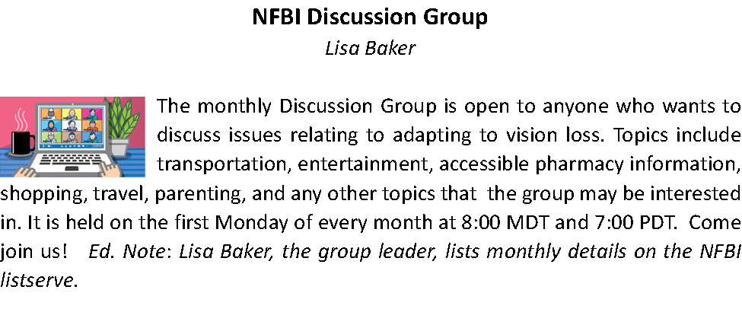
NWABA Winter Events
Sam Picciano
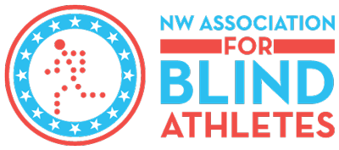
NWABA’s second office located in Boise, Idaho offers in-person, ongoing sports and recreational events by season. This programming is catered toward individuals who are blind and visually impaired and focuses on adaptations and modifications for access and skill building. Events are typically held on Friday evenings and Saturday late mornings/afternoons, however, an occasional weekday or weeknight experience pops up to add in novel experiences. The Southwest Boise crew of athletes and volunteers considers themselves a family and holds engagement events throughout the year. Want to join the crew? Email Mandi or Sam at mlucas@nwaba.org or spicciano@nwaba.org.

Please see the following event list for February and March:
Descriptions and transportation points are listed on our website at Idaho – NWABA

Event Name/Title: Goalbowl Date: Thursday, 02/01/2024
Time: 6:00 PM – 8:00 PM Place: Hawthorne Elementary School

Event Name/Title: Goalbowl Date: Thursday, 02/22/2024
Time: 6:00 PM – 8:00 PM Place: Hawthorne Elementary School

Event Name/Title: Sunset Snowshoe Clinic Place: Bogus Basin
Date: Friday, 02/23/2024 Time: 5:00 PM – 7:00 PM

Event Name/Title: Curling Experience Place: Ice World
Date: Wednesday, 02/28/2024 Time: 10:00 AM – 12:00 PM

SWID MARCH
Event Name/Title: AM Ski/Snowboard Clinic
Date: Saturday, 03/02/2024 Time: 9:00 AM – 12:00 PM
Place: Bogus Basin

Event Name/Title: PM Ski/Snowboard Clinic
Date: Saturday, 03/02/2024 Time: 1:00 PM – 3:00 PM
Place: Bogus Basin

Event Name/Title: AM Ski/Snowboard Clinic
Date: Sunday, 03/03/2024 Time: 9:00 AM – 12:00 PM
Place: Bogus Basin

Event Name/Title: PM Ski/Snowboard Clinic
Date: Sunday, 03/03/2024 Time: 1:00 PM – 3:00 PM
Place: Bogus Basin

Event Name/Title: Water Aerobics Date: Friday, 03/15/2024
Time: 5:30 PM – 7:30 PM Place: Central Idaho Aquatic Center

Event Name/Title: Fitness Walk/Beginner Hike
Date: Saturday, 03/16/2024 Time: 2:00 PM – 4:00 PM

Place: Intermountain Bird Observatory's Diane Moore Nature Center,7191 ID-21, Boise, ID 83716

(PRESIDENT, Continued from page 1)
Our theme is “Living Ambitiously.” Hurry and get registered so our affiliate can have an ambitious, enthusiastic convention. Let’s beat last year’s attendance record of 49 members.
I want to thank everyone who participated in our state fundraiser, “Invest in Our Future.” We raised over $12,000 through this event. We plan to make this an annual event and will be incorporating ways to invite all to participate.

It’s not too early to plan to attend our national convention, July 3-8 at the Rosen Center, Orlando Florida. Room rates are $129.00 singles/doubles, and $139.00 triples/quads. 13.5% tax per night is additional. To reserve your room, call 800-204-7234, and state that you are registering under the NFB room block. Your credit card will be charged $146.00 at the time of registration. Last year, five members attended our national convention. The affiliate will provide some assistance, so let’s increase our numbers in 2024.
Stay warm and safe. Spring is coming and the state convention will be here before we know it. Let’s get registered and build the National Federation of the Blind of Idaho.

Medical Device Nonvisual Accessibility Act
Justin T. Young, Ed.D
I wanted to let you know we have some breaking news regarding the Medical Device Nonvisual Accessibility Act. On January 18, 2024, the Medical Device Nonvisual Accessibility Act was introduced in the United States Senate. It’s bill number is S.3621 and it was introduced by Senator Margret Hassan (D-New Hampshire) and Senator Mike Braun (R-Indiana).
This is wonderful news because it’s the first time we have had a Senate bill on the topic. The bill is bipartisan, and it’s very helpful both sponsor and lead cosponsor are on the relevant committee. Great work to all who helped get us to this point!
Thanks, and we enjoyed being with you all in Washington D.C.!
A Life Well Lived
Ramona Walhof
Mary Ellen Halverson Jan. 1945 to Dec. 2023

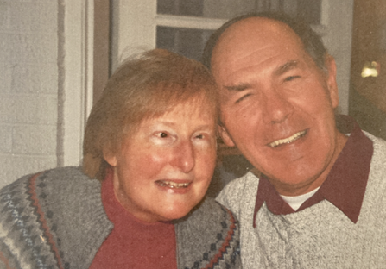
For the NFBI and so many more, the loss of Mary Ellen Halverson is a great one. She was quiet, calm, strong, wise and loving. And so many loved her back!
Although legally blind as a child, Mary Ellen struggled through school. As her sight
Photo: Mary Ellen and Ray continued to decrease during college, she decided to seek training at the Orientation and Adjustment Center of the Iowa Commission for the Blind. She met Joann Wilson at an NFB College Day, and the two made a pact to train together, although neither really wanted to. Dr. Kenneth Jernigan was director of this agency at the time, and Mary Ellen looked up to him for the rest of her life.
In 1968 she married Ray, and they raised two children, Holly and Mat. When Ray took a job in Boise in 1973, the family moved to Idaho and stayed. Mary Ellen stayed home to raise the kids for several years, but in the mid 1980's, she went to work as Braille teacher for ICBVI. Her students loved her as a role model and as a teacher. Ed McHugh who directed the ICBVI in the early 90’s once said to me: "It turns out I lied to the Commission Board when they hired me." Of course I needed an explanation. He said, "They asked me if I could travel independently with a white cane, and I said, ‘Yes.’ But that was before I met Mary Ellen and observed her travel skills.” Mary Ellen was a role model and teacher to all kinds of people in so many situations. Mary Ellen was also an active leader in the NFB of Idaho for more than 40 years. She held office repeatedly in the Treasure Valley Chapter and in the state affiliate.
During the last quarter of a century, eight grandchildren have called Mary Ellen and Ray Grandma and Grandpa. Mary Ellen loved to tell about them, but usually waited to be asked.
As Mary Ellen's health deteriorated, Ray was her faithful and cheerful assistant and care giver. She valued his care as she became more and more dependent. She worshipped at Whitney Baptist Church which was an important part of her life, and she had many close relationships there. Mat and Holly planned a beautiful memorial service at the church on January 13. (Continued on next page)
I depended on Mary Ellen for advice and support when I was President of the NFB of Idaho, in personal matters, and to share stories about events and people we both knew.
At the memorial service, Sondra Johnson made a beautiful presentation and shared some of the delightful experiences she had with Mary Ellen. Although we may not all be able to tell the stories as well as Sondra, we understood and loved the Mary Ellen she dscribed.
2024 BELL and Beyond is Coming!
Alison Steven
Save the date! NFB of Idaho BELL and Beyond 2024 will take place at Pilgrim
Cove Camp in McCall, Idaho from July 21 through 26, 2024. See the attached
flyer for more information, and mark your calendars. BVI youth aged 7
through 17 are invited to join us for this amazing opportunity.
We build blindness skills, self-confidence and share incredible experiences.
Please reach out with any questions, and keep an eye on your email inbox for
the registration link coming in February!

Your Donations Help NFB-Idaho Members
Reach Our Goal of Personal Independence
The National Federation of the Blind provides advocacy, training, and access to opportunities that help individuals  with disabling vision loss become independent. Your tax-deductible donations help us to help our members "live the lives they want!"  Use the URL below or the QR Code to the right to visit our online donation page. Donate using any credit or debit card. All transactions are secure and managed by Square.  NFB-Idaho Donation URL: https://bit.ly/3tFCxsK | NFB-Idaho Donation QR Code  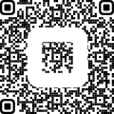

If you prefer, you can mail your donation to the NFB-Idaho Treasurer, this address: | Don Winiecki  Treasurer, National Federation of the Blind of Idaho  1422 E. Woodvine CT Boise, Idaho 83725

